Daily exchange rate close
Bank of Canada Daily Exchange Rates page
http://www.bankofcanada.ca/rates/exchange/daily-exchange-rates/

Current exchange rate
Bloomberg Markets Currencies page
https://www.bloomberg.com/markets/currencies

Daily TSX close (Abandoned)
Globe and Mail Investor Markets page
https://www.theglobeandmail.com/globe-investor/markets/

Daily Dow close (Abandoned)
MarketWatch Investing page
http://www.marketwatch.com/investing/index/djia

Daily TSX close
Bloomberg Markets page
https://www.bloomberg.com/quote/SPTSX:IND

Daily DOW close
Bloomberg Markets page
https://www.bloomberg.com/quote/INDU:IND

Snapshots of web pages mymoney app is scraping from

http://www.bankofcanada.ca/rates/exchange/daily-exchange-rates/

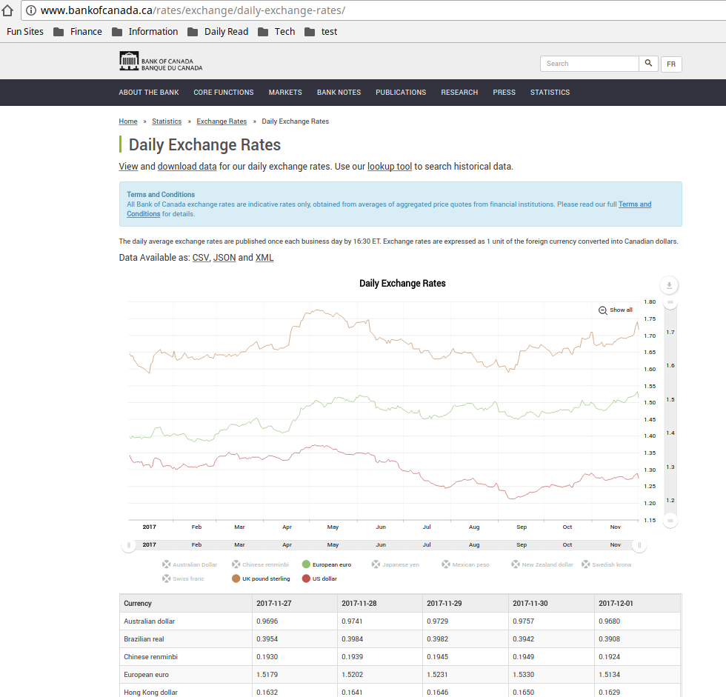

https://www.bloomberg.com/markets/currencies

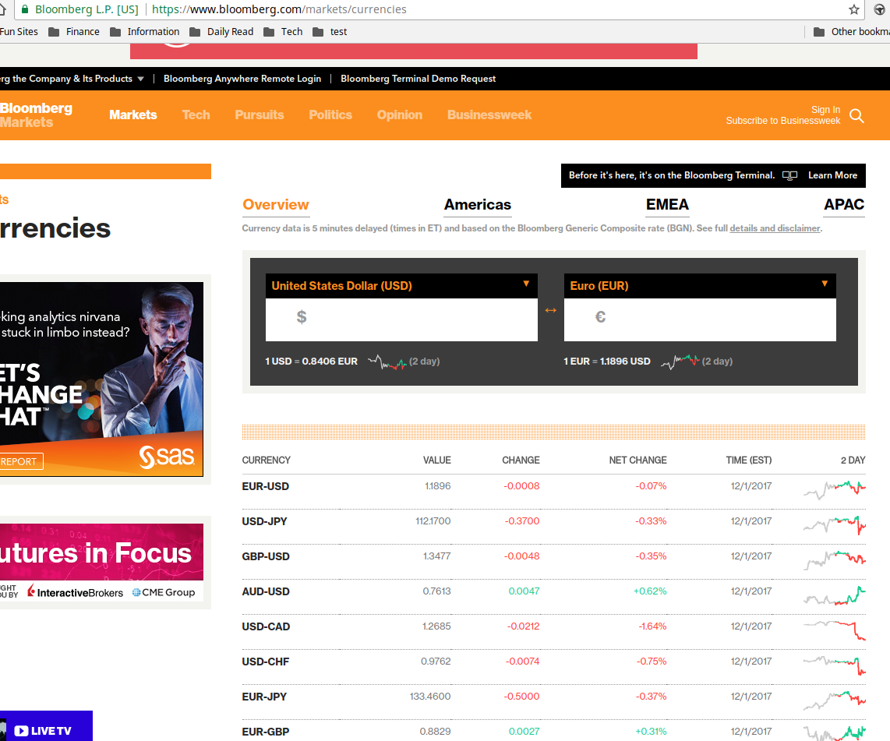

https://finance.google.ca/finance?cid=675094

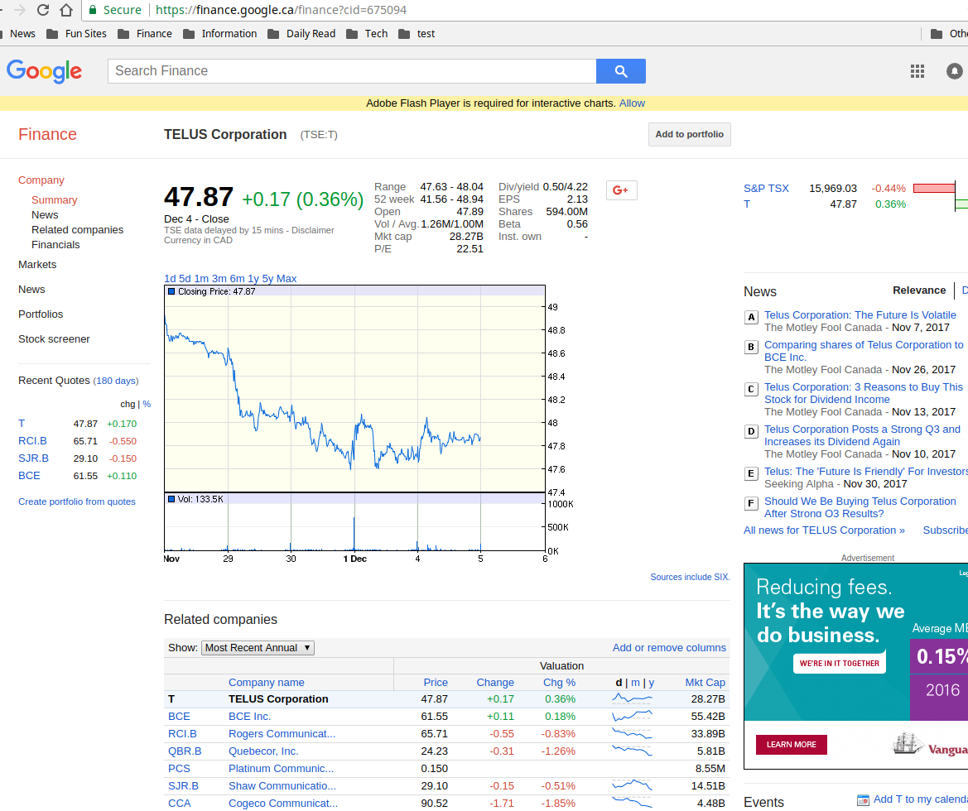

http://www.theglobeandmail.com/globe-investor/funds-and-etfs/funds/summary/?id=57859&cid=2581

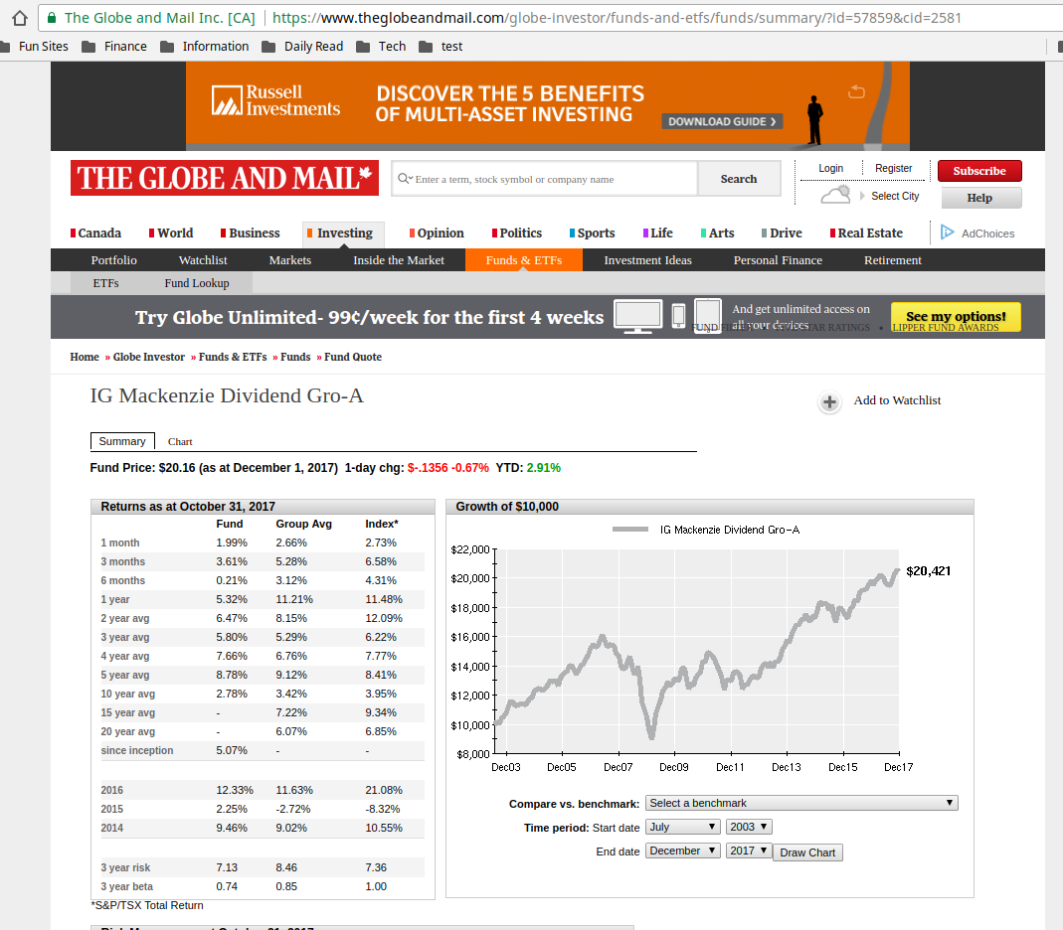

https://www.theglobeandmail.com/globe-investor/markets/
(Abandoned)

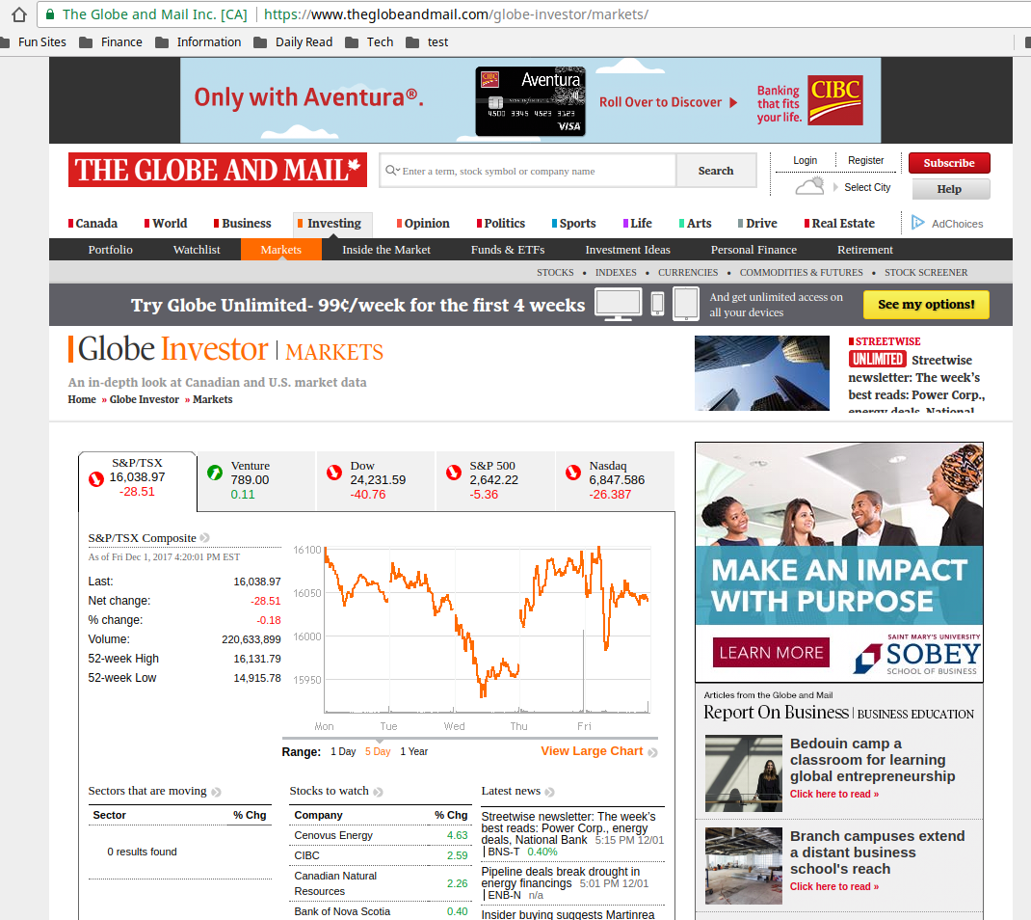

https://www.bloomberg.com/quote/SPTSX:IND

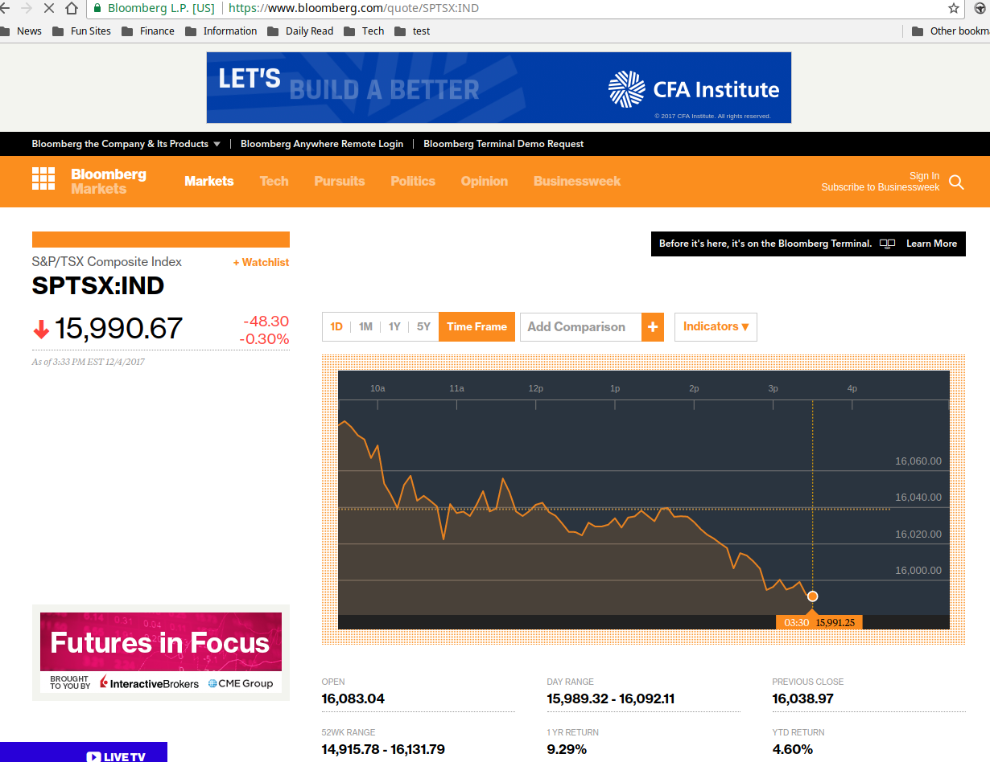

https://www.bloomberg.com/quote/INDU:IND

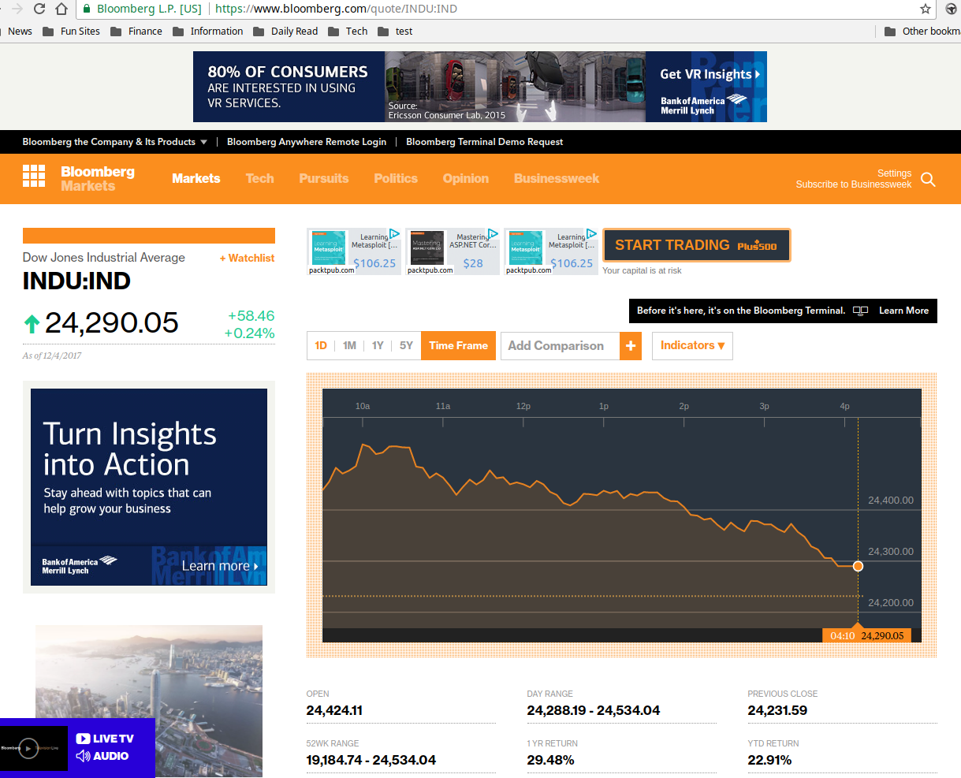

http://www.marketwatch.com/investing/index/djia
(Abandoned)

